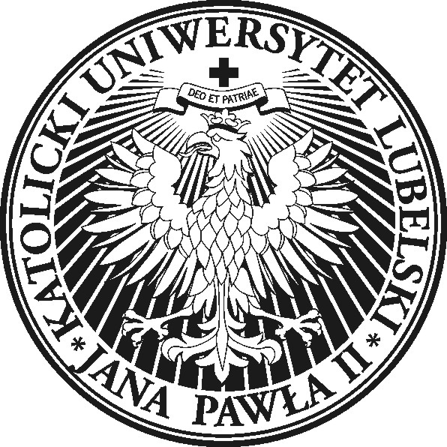
John Paul II Catholic University of Lublin
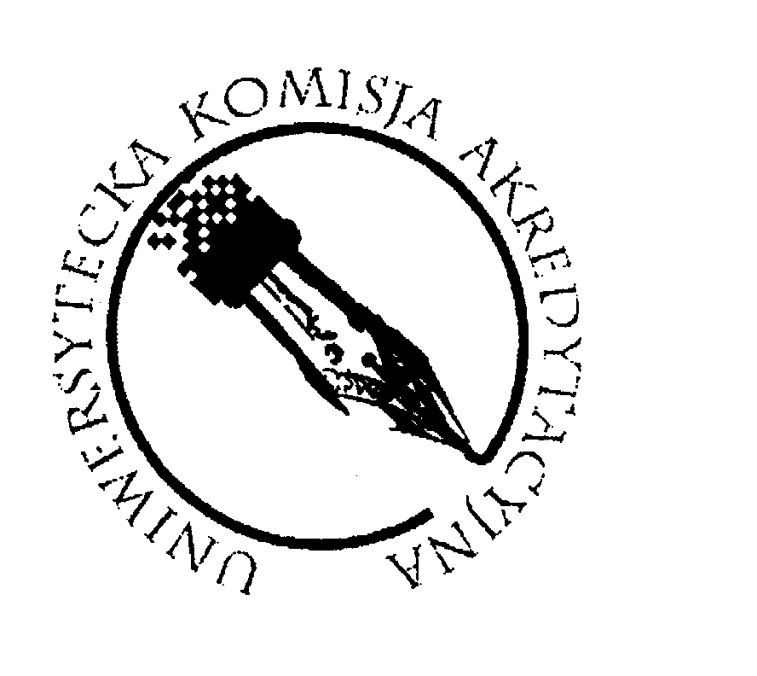

Institute of Pedagogy, Faculty of Social Sciences
Al. Racławickie 14, 20-950 Lublin; tel. 81 4545319,
e-mail: instped@kul.pl

Call for Participation

for the Institute of Pedagogy KUL Anniversary Conference

Lublin, 17-19th October 2016

Institute of Pedagogy of the John Paul II Catholic University of Lublin, is proud of being the oldest Polish Pedagogical Institute in terms of the tradition of teaching and research in the field of education. It is a descendant of Lublin Pedagogical Institute, and Department of Education created in 1919, a year after regaining independence by Poland and a year after the foundation of the KUL University. In its long history it has gone also through a period of suspension of its activity during the communist time – the pedagogical studies have been suspended in 1953 and totally closed in 1956. Year 1981 brought the reactivation of the KUL pedagogical studies – they were reactivated in the academic year 1981/1982. It means that this year we are celebrating the 35th anniversary of this event. In 1981 the Pedagogical Section and the Institute of Pedagogy in 1996 undertook its activity in the field of teacher training and building the body of pedagogical knowledge within the KUL community and all over Poland
Celebrating the 35th Anniversary of restoring the pedagogical studies at KUL we want to undertake a reflection on the practice of education and teacher training. To reach this aim we plan to organize a an Anniversary Conference entitled: Adequate pedagogy in the field of the great tradition.
The choice of the theme was inspired by the statements of two authors, which we include in our deliberation, namely, first, Karol Wojtyla, who in the 'Lublin lectures on ethics' referred to the category of "adequate anthropology" as the basis for the creation of "adequate ethics" and pointed to the original concept of' personalistic norm showing a man as a subject of ethical thinking and acting, and then Leszek Kolakowski, who dreamed of pedagogy practiced on the basis of a great tradition.
Pedagogical research and practice is not so much associated with constantly reporting new and unproven ideas, but much more with the desire to explore the profile of education in our centers and stimulate interests in our own past and identity. Shaping the authentic identity indicates the elements that are at the basis of pedagogical research and practice in each of our centers and manifest themselves in the collective thinking of the Institute or Faculty, as well as each of us as their employees.
Starting from Lublin origins of pedagogy in our environment, we want to invite other scientific communities practicing academic pedagogy, to exchange thoughts and experiences connected with this issues and we would like to invite everybody to come to Lublin - as representatives of your own traditions of pedagogical research and practice and participants in the debate, which we suppose will be just the beginning of discussion over the great tradition of pedagogy in Poland and also in other countries.
The search for adequate pedagogy, inspired by the aspirations of the late fifties of the twentieth century by Karol Wojtyla in the context of referring to "adequate anthropology and ethics" could direct our discussion to explore our past practice to seek the adequacy of the pedagogy in the history of our centers, and this in turn, could provide an important basis of our reflection on the adequacy of the academic pedagogy practiced today and going into the future.
In our debate, we could take the following topics:
- Origins of pedagogy practiced in Poland and in Europe - including the role of Masters
- Methodological traditions of pedagogical research and practice in our centers
- The practical implications of pedagogical research and practice in our communities - as examples of good practice
The conference is planned for 17-19 October 2016 at the John Paul II Catholic University of Lublin and each of the above topics could determine one of the days of our meeting.
The conference was initially adopted by the Presidium of the Committee of Pedagogical Sciences of the Polish Academy of Science (PAN) and we hope for the presence of the members of the Committee of Pedagogical Sciences PAN. We also hope to host the joint meeting of the Committee of Pedagogical Sciences PAN and the Directors of Institutes of Education and Deans of Faculties of Education from all over Poland. We also expect the presence of foreign guests, including scientists especially from European countries. We are also open to suggestions for creating other specific groups and thematic sessions. We thank you in advance for every comments and suggestions.
Important dates:
By 31th August 2016 – submission of abstracts of conference paper/poster/discussion
The conference program will be sent at the beginning of September
Participation in the conference is free of charge.
We plan to publish a book with the reviewed conference papers.
With a cordial invitation to participate
Rev. Professor Marian Nowak PhD hab.- Chairman of the Organizing Committee (phone: +48 609754598);
Secretaries of the Conference:
Dr Catherine Braun (phone: +48 501 347 889),
Rev. Marek Jeziorański (phone: +48 694 619 746);
e-mail: pedog@kul.lublin.pl

